**Exp.3 LCD interface- programmable digital data display system**

CIRCUIT DIAGRAM:

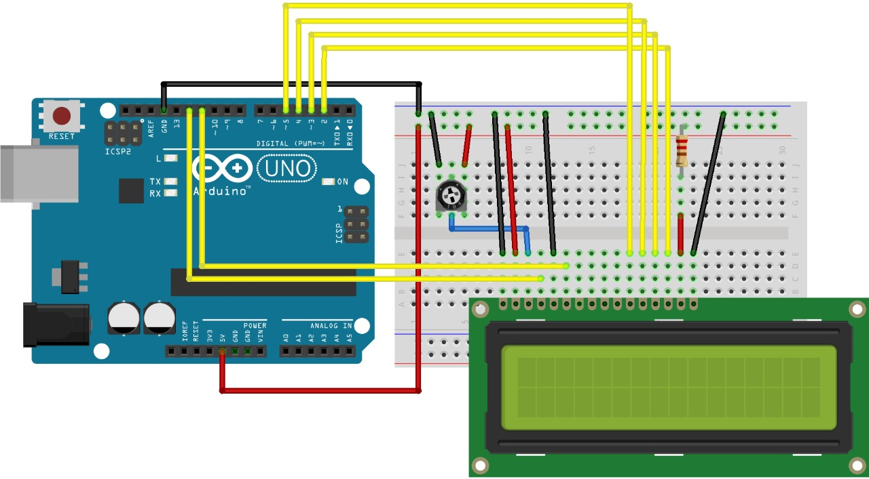

CONCEPT USED:

LCD displays do not emit light. Instead they block the passage of light, like little windows which open and shut the let light through. The liquid crystals used inside LCD displays are sandwiched between two layers of polarized material. By changing the orientation of the liquid crystals they allow light to pass or they block the light entirely.

Because transmissive LCD displays (the type we will be using) work by blocking light they require a backlight. Several methods have been used to create back lights including electroluminescent panels and fluorescent tubes.   these days the most common form of backlight is an LED, in fact so-called LED televisions are usually just LCD screens with an LED backlight system.

Another type of LCD display, the passive-matrix display, does not require a backlight, it works using reflected light. This type of display is often found in digital watches.

The low cost and versatility of LCD displays makes them suitable for a number of different applications.

LiquidCrystal Library - Hello World

Demonstrates the use a 16x2 LCD display. The LiquidCrystal

library works with all LCD displays that are compatible with the

Hitachi HD44780 driver. There are many of them out there, and you can usually tell them by the 16-pin interface.

This sketch prints "Hello World!" to the LCD

and shows the time.

The circuit:

* LCD RS pin to digital pin 12

* LCD Enable pin to digital pin 11

* LCD D4 pin to digital pin 5

* LCD D5 pin to digital pin 4

* LCD D6 pin to digital pin 3

* LCD D7 pin to digital pin 2

* LCD R/W pin to ground

* LCD VSS pin to ground

* LCD VCC pin to 5V

* 10K resistor:

* ends to +5V and ground

* wiper to LCD VO pin (pin 3)

CODE:

#include <LiquidCrystal.h>

LiquidCrystal lcd(12, 11, 5, 4, 3, 2);

void setup()

{

lcd.begin(16, 2);

lcd.print("hello, world!");

}

void loop()

{

lcd.setCursor(0, 1);

lcd.print(millis() / 1000);

}

Learning and Observations:

In this experiment we learnt the following:

1. Basic circuit building with Arduino uno.

2. Interfacing a LCD with Arduino uno.

Precaution:

1. The LED should not be connected in reversed direction because it doesn’t allow passing the current and circuit does not completed and LED will not glow.

2. The connections should be tight.

Learning Outcomes:

Via this activity we learn and acquire the skills about the following:

1. The application and usage of digital input/output pins of Arduino uno.

2. How LCD work and their interfacing with Arduino Uno.

3. Understood the syntax to write the basic code in Arduino IDE.

4. How to Identify the P-N Junction of LED.